Description of the Product

7 HP ELECTRIC OUTBOARD MOTOR
SEAGÖ SE7 Series is an electric outboard motor has a rated voltage is 48V, and the maximum power of 5.1 Kw, Compared to the existing gasoline models, the electric outboard is quieter and more environmentally friendly because they run on electricity instead of fuel. Additionally, we use Permanent Magnet Synchronous Motors, which have reduced noise, extended lifespan, increased efficiency and require less maintenance.
Relevant Boat Class
Small vessels of various materials including inflatable boats, wooden boats, FRP boats, plastic boats and similar, with lengths ranging from 2 to 4 Metres, are a good fit for the electric 7-horsepower outboard motor.
Recommended Battery
For this Model, 48V 100 AH or 48V 150 AH LiFePO4 – Lithium Ferrous Phosphate battery packs can be utilized
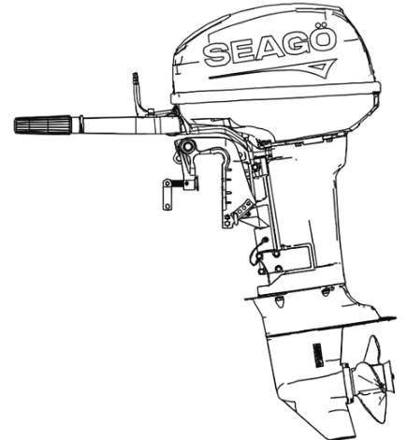
Model Options
SE7BS – Tiller Control Short Shaft
SE7BL – Tiller Control Long Shaft

Specifications

Product Model | SE7 Series
Rated Power | 5.1 kW
Rated Voltage | 48 V
Motor Type | PMSM
Sensor Type | Magnetic Encoder
Steering System | Tiller Control
Maximum Speed | 5000 - 5500 RPM
Gear Ratio | 2.08
Transom Height | S:440mm /L:568mm
Weight {Kg} | S:30 Kg / L: 31 Kg
Cooling System | Water Cooled
Gear Position | Forward/Neutral/ Reverse

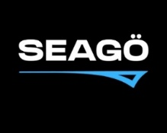
www.seago.in sales@seago.in +91-8606366633
7 HP ELECTRIC OUTBOARD MOTOR

